Assignment 3

Automate the process of continuous integration using Jenkins

1.Install Jenkins on Plain VM

2.Create Jenkins jobs for a application

3.Hook Git Hub repository to Jenkins job

4.Configure automated Build

5Create Cron jobs in Jenkins

6.Create pipeline view in Jenkins

7Deploy the application on plain VM/firebase

8.Configure the DB Credentials in a property file

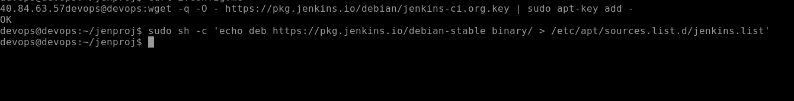

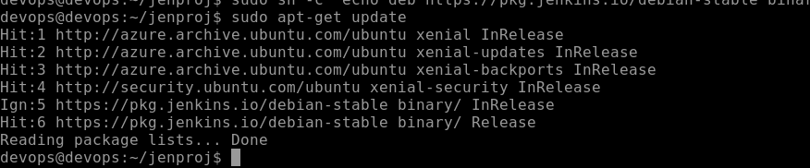

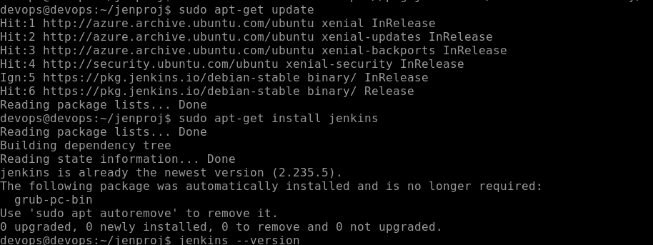

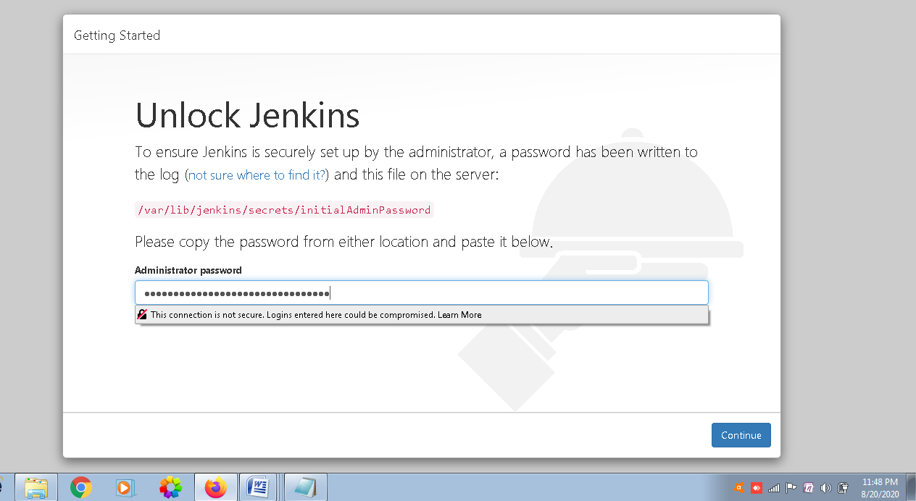

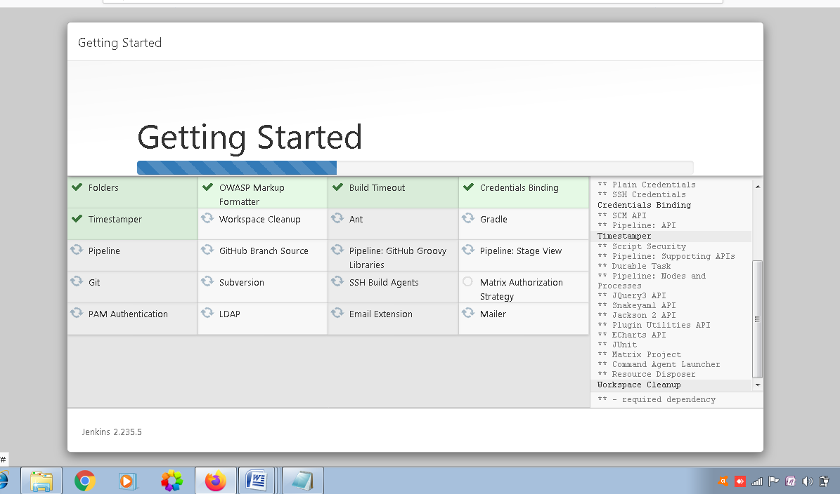

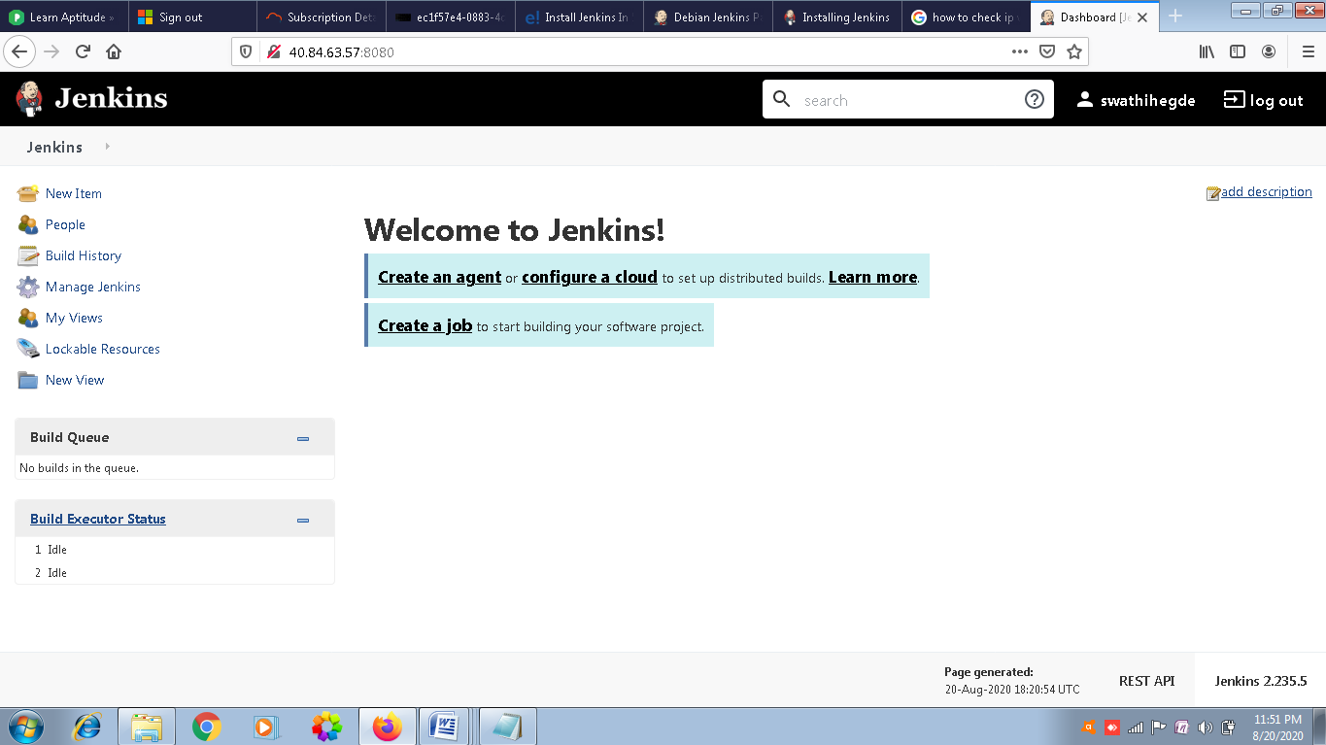

Now I ll be installing Tomcat server as well and hosting it on port 8090 as on 8080 there is already Jenkins running.

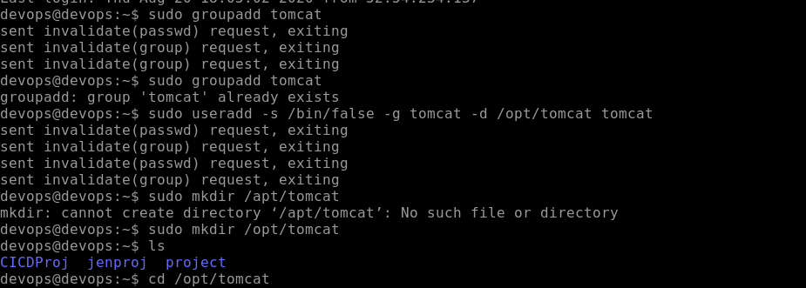

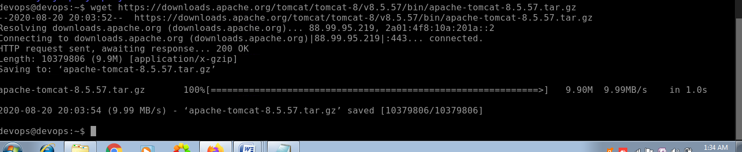

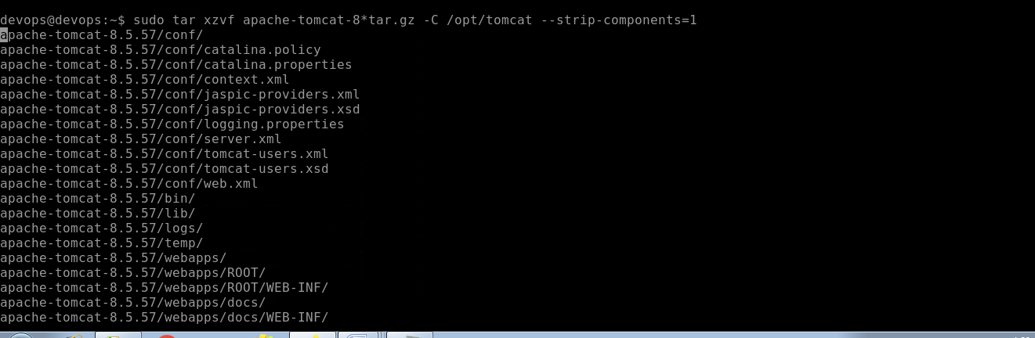

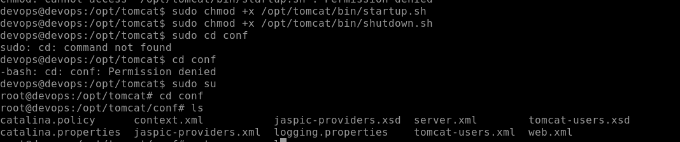

Make changes in server.xml and change the default 8080 port number to 8090

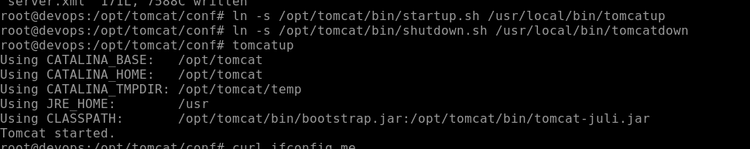

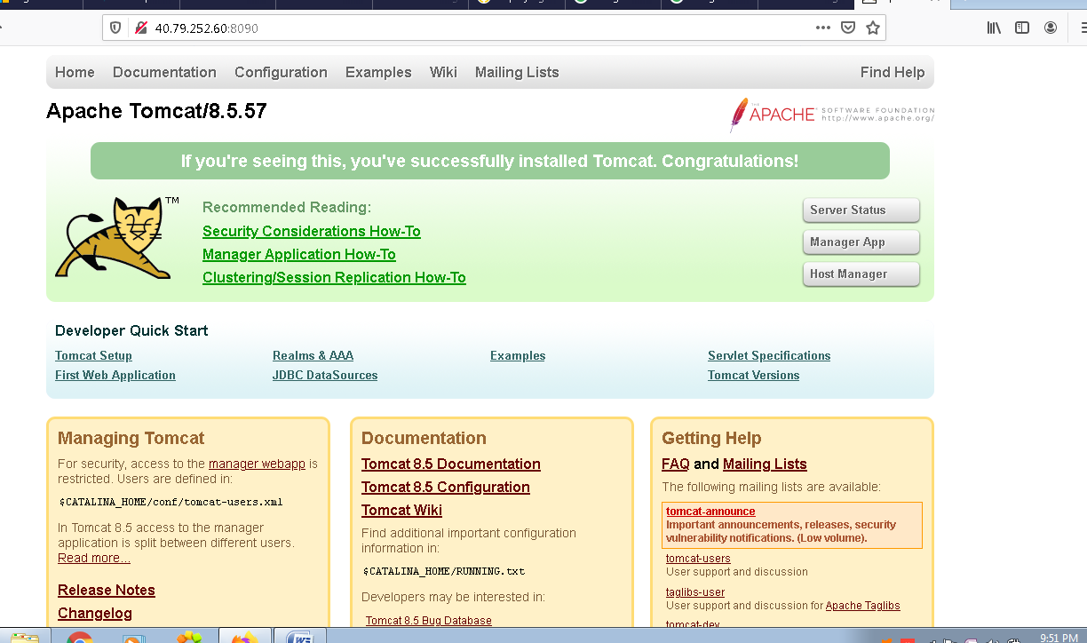

Now we will be cloning one sample Web project from internet and also we will be pushing the code to our github repository.

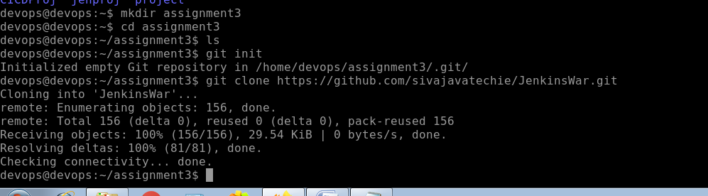

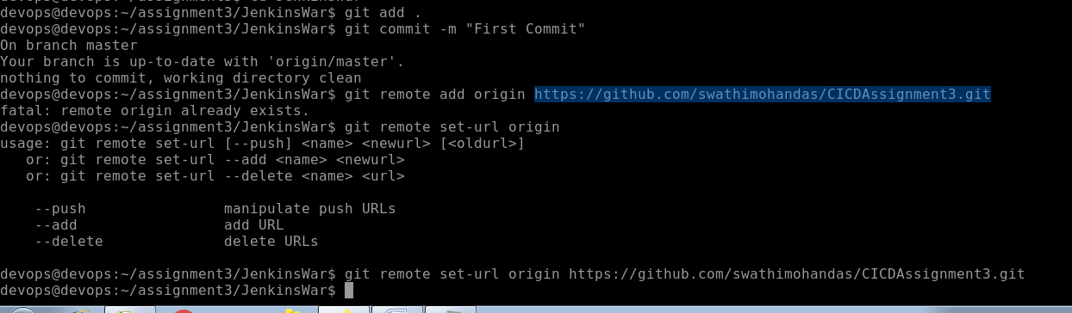

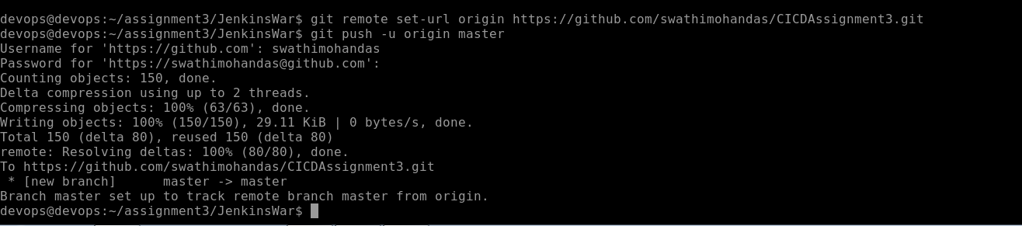

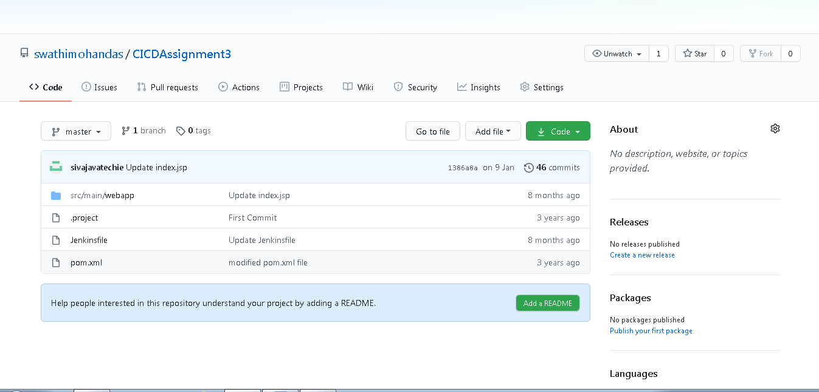

Now we will be setting up the Jenkins Job in Jenkins

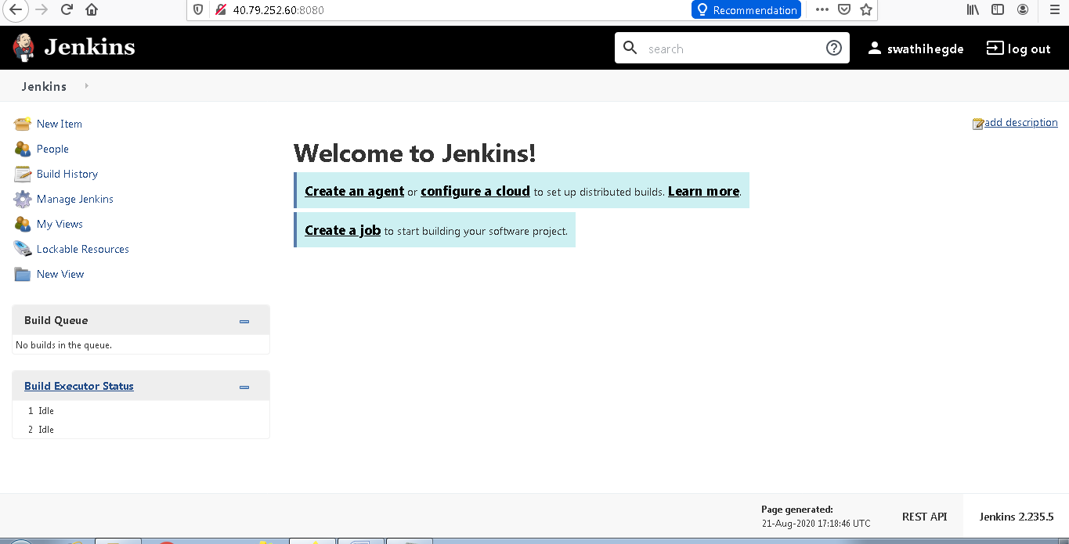

Then we will go to manage Jenkins & Global tool configuration

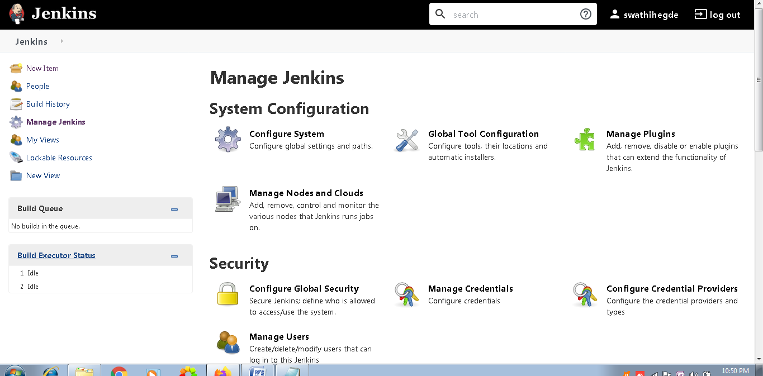

Now we will configure for 2 tools

1 for Git

2 for Maven

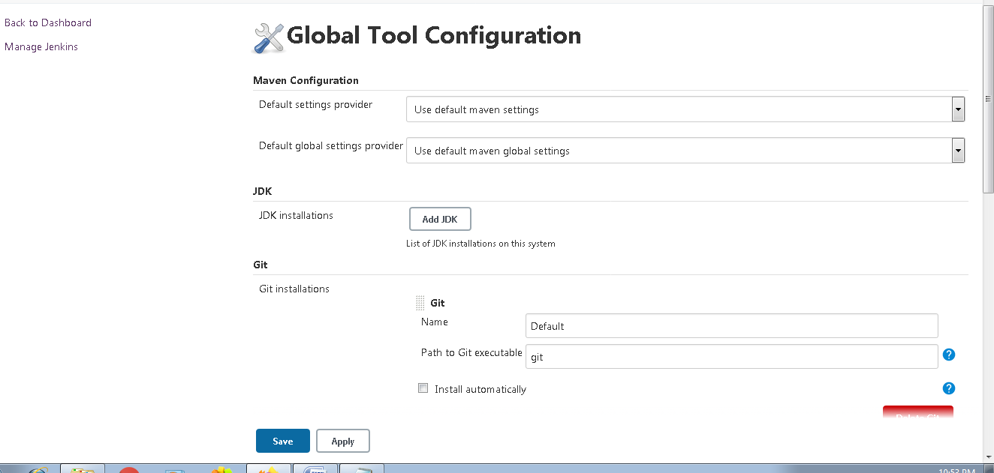

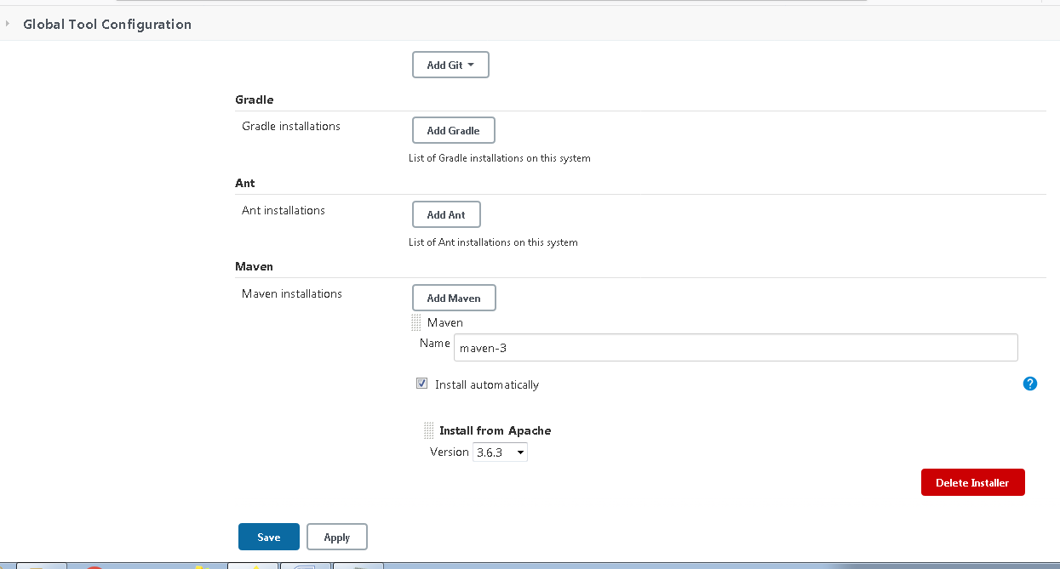

Now we will be creating the Jenkins Pipeline as follows

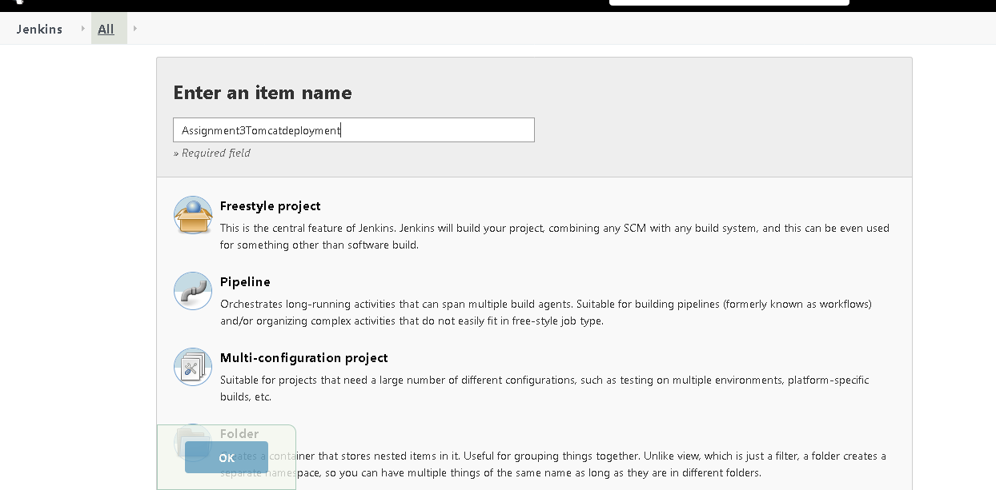

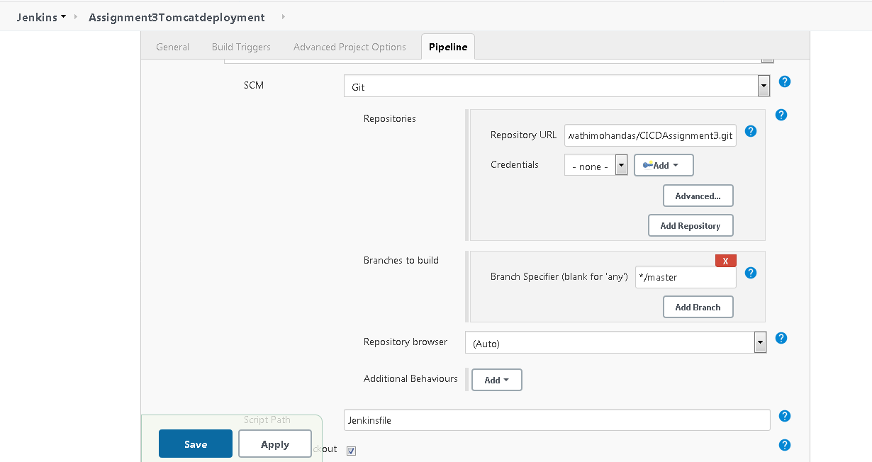

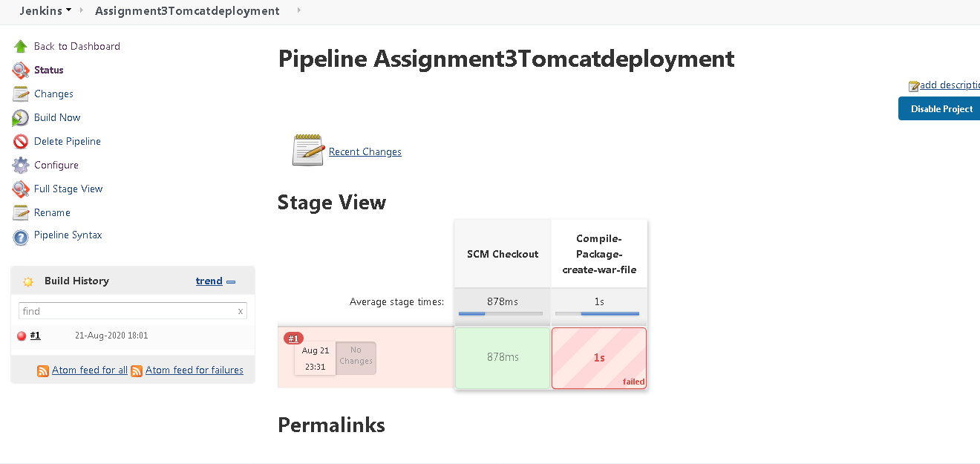

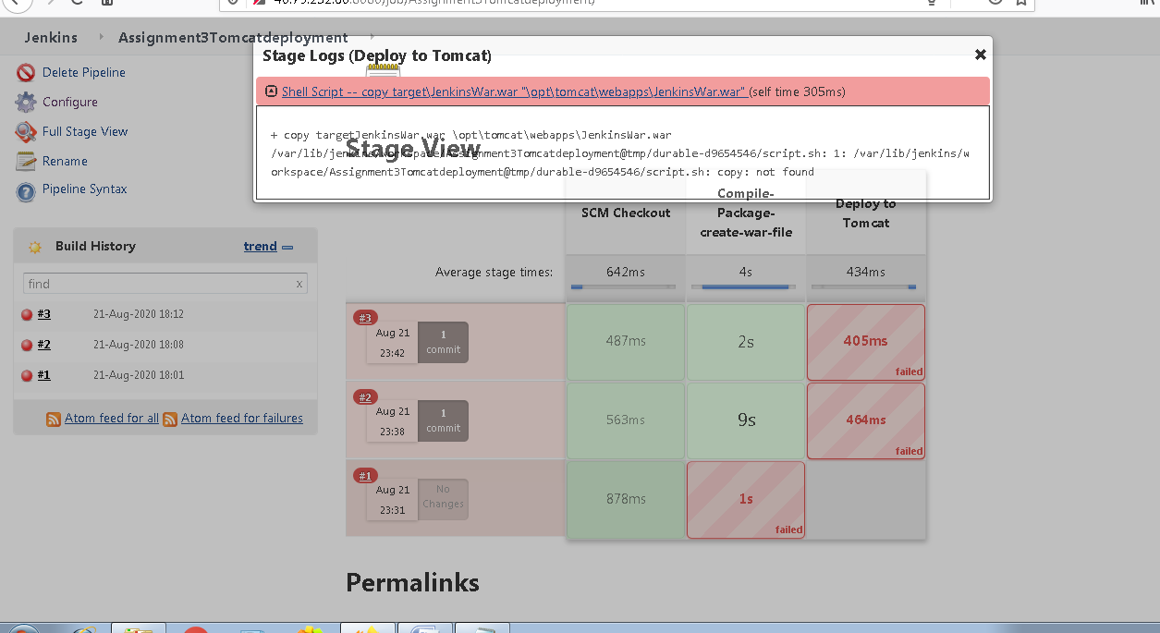

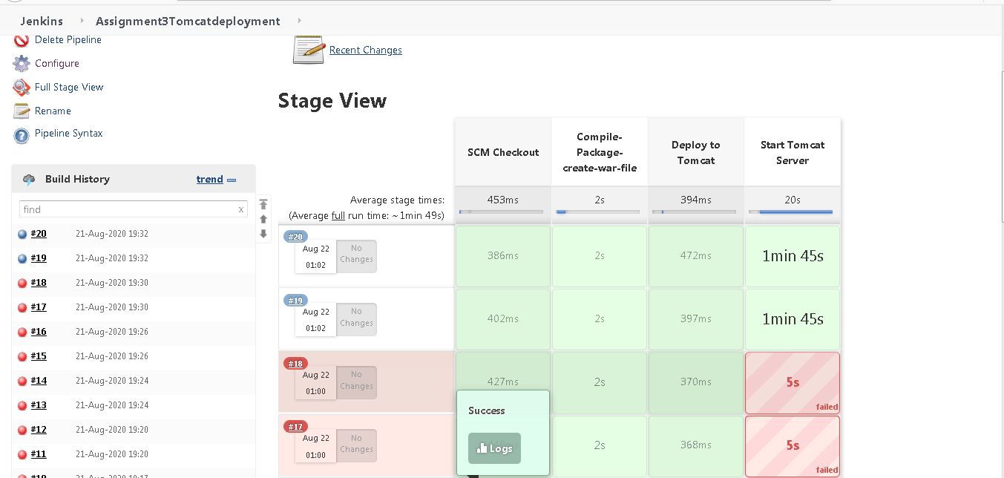

After resolving all permissions issues the War file was deployed to tomcat server

Now we will go to tomcat server webpage on 8090 port

But we could see below error

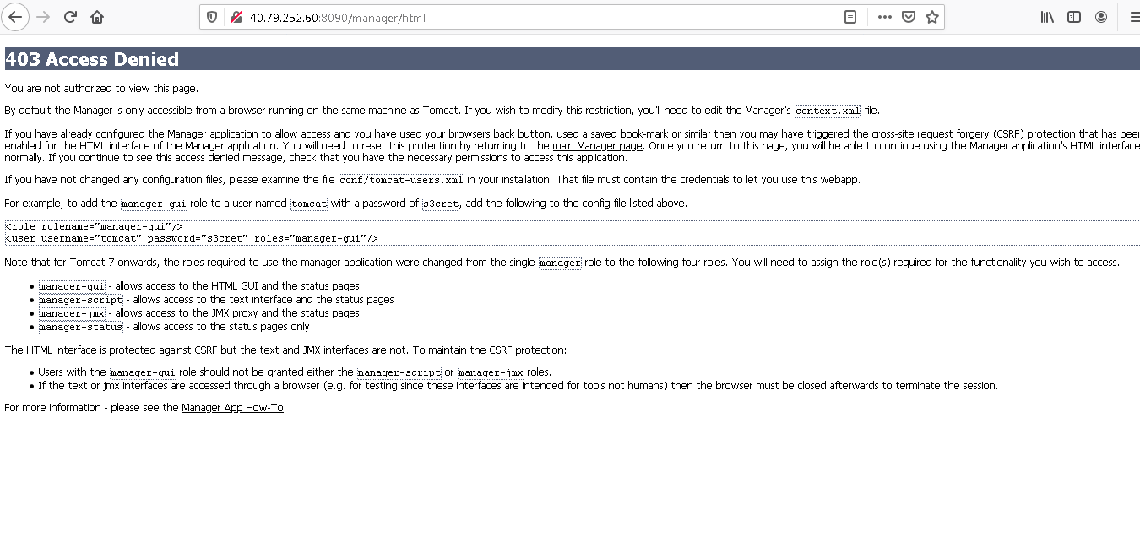

Now we will make changes to the conf file and will be updating the credentials

In server.xml

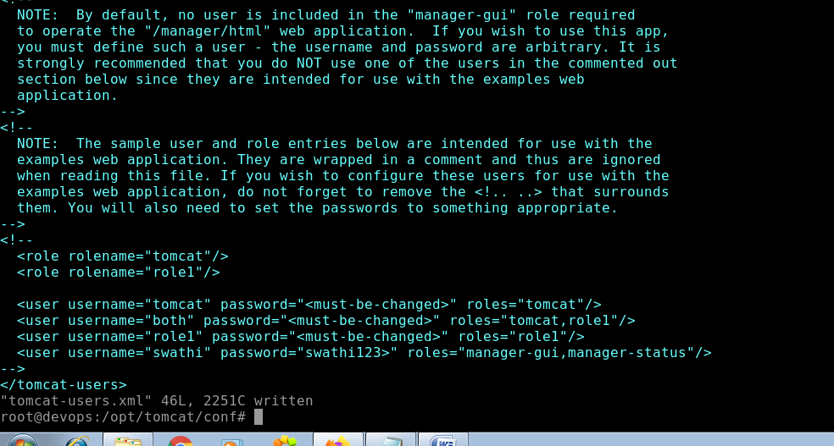

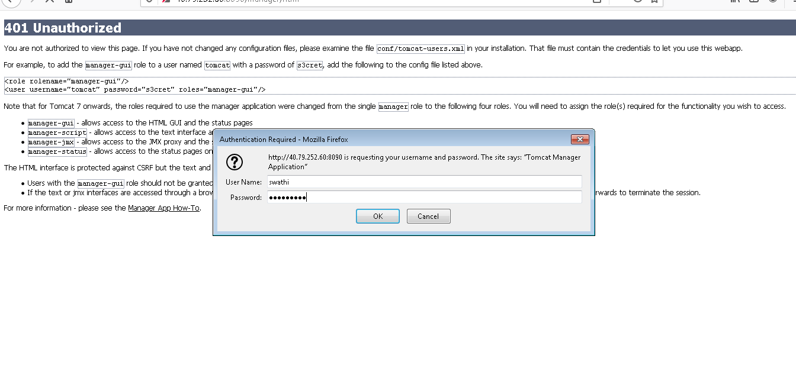

After providing credentials we could see below o/p

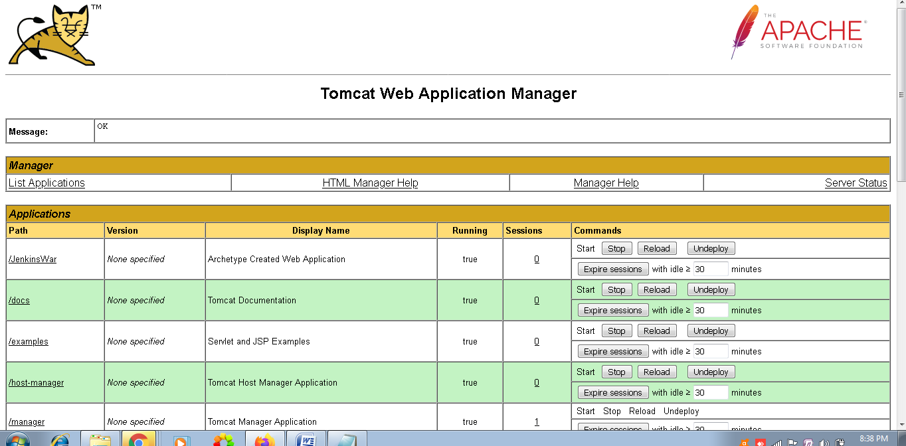

Our application file i.e JenkinsWar.war has been deployed to tomcat.

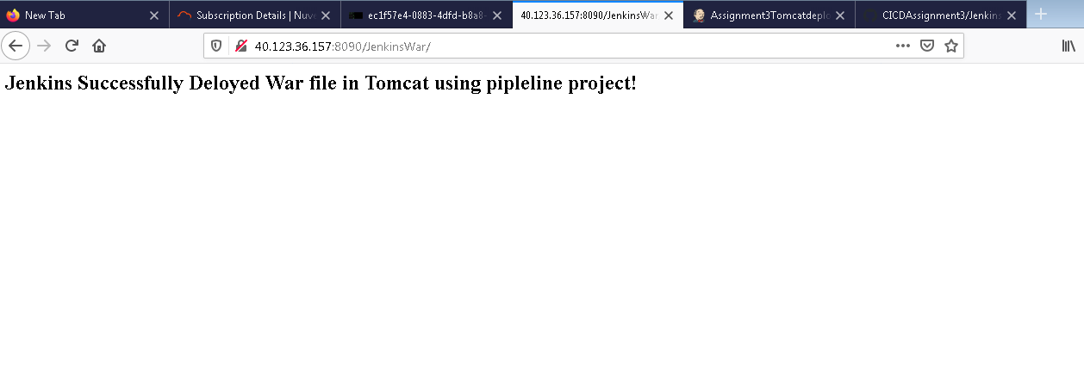

Now if we want to automatically trigger the Jenkins pipeline whenever there is a new commit in the Github

Then we will do that as follows

Open Github and the project repository

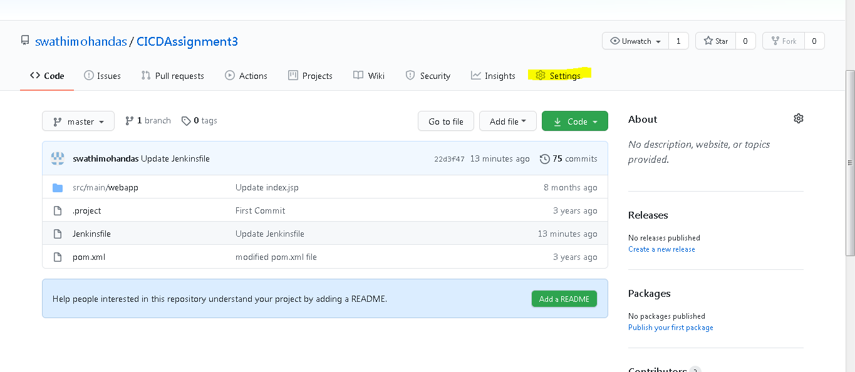Then Go to settings tab

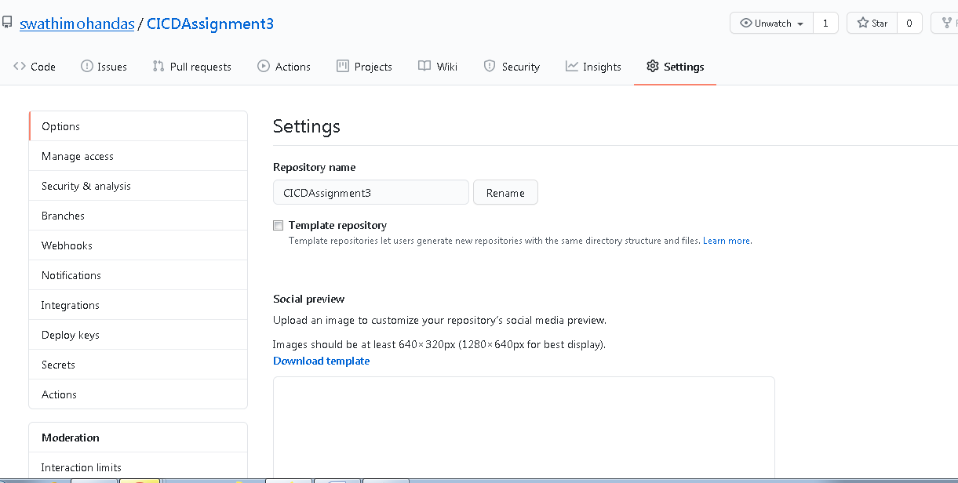

Click on webhook , Then add webhook

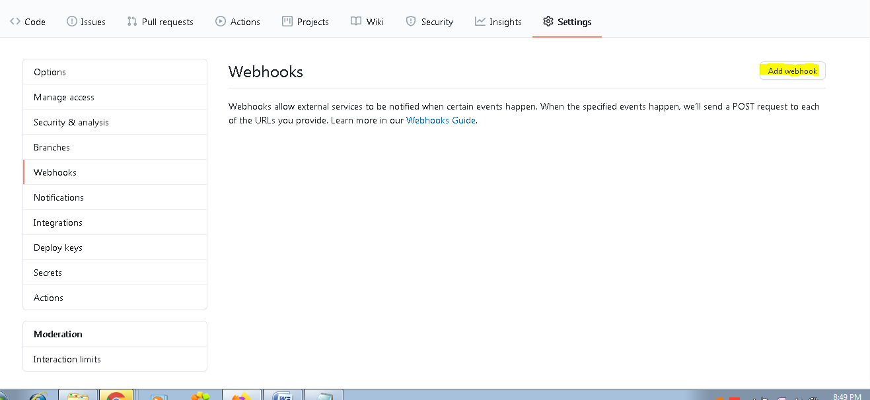

Then update the payload url with the Jenkins url as follows

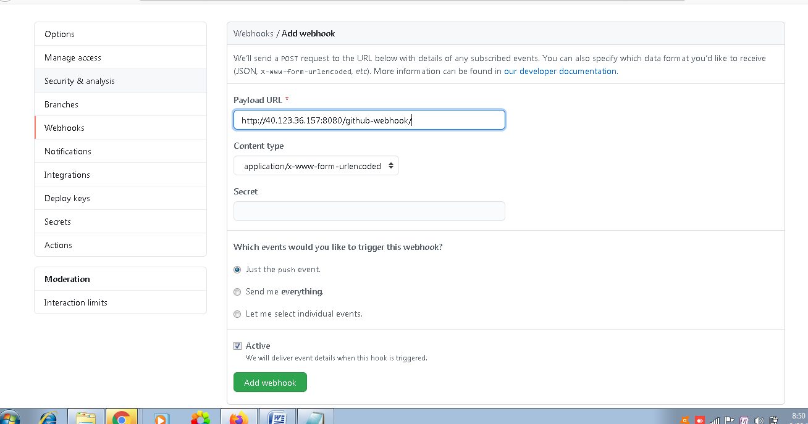

I am updating it only for push event

anges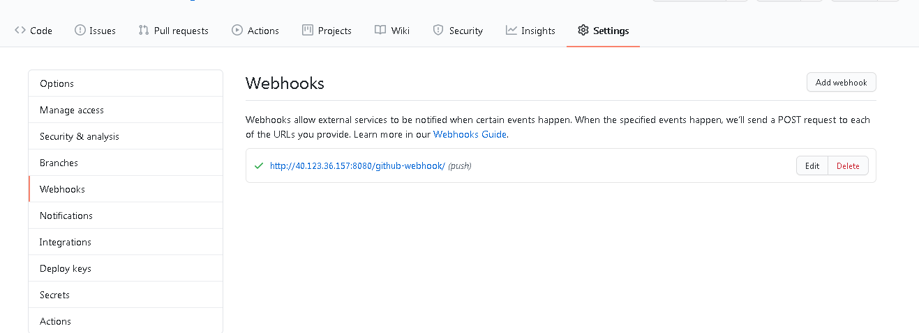

So now whenever there is a push event happening or the new changes are committed to the file the Jenkins pipeline job will be triggered.

Now I will be creating 1 dummy file for testing and will be performing commit as follows.

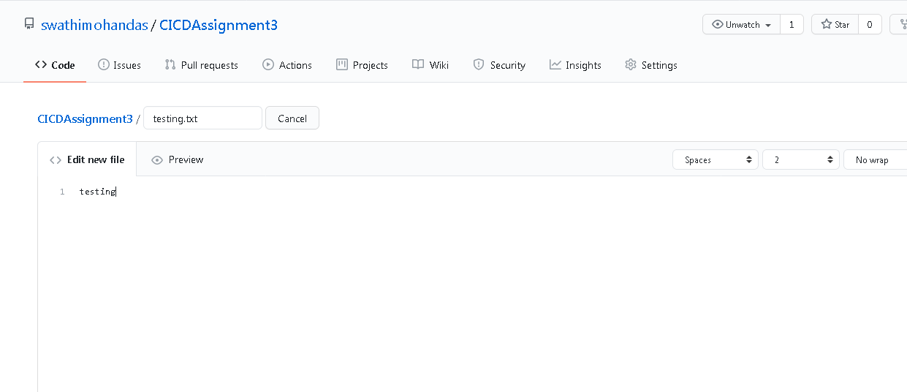

Also we need to update the Jenkins job as follows

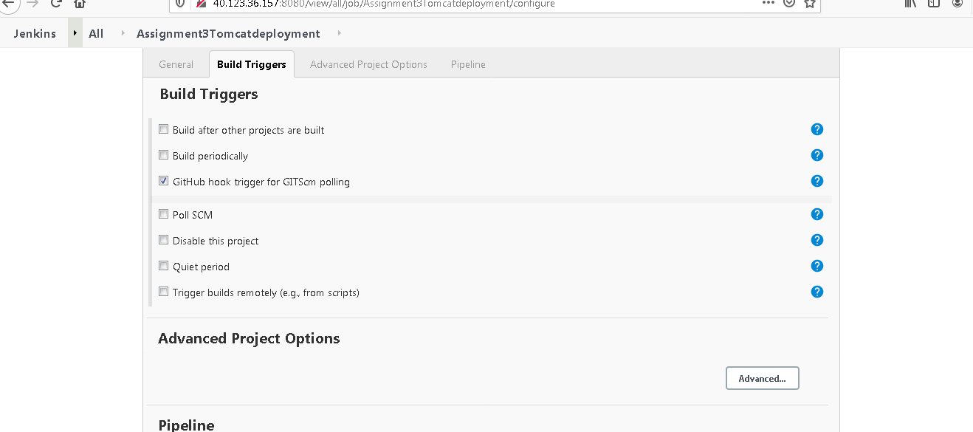

Now we just made 1 commit,and could see the jnekins job is triggered as follows.

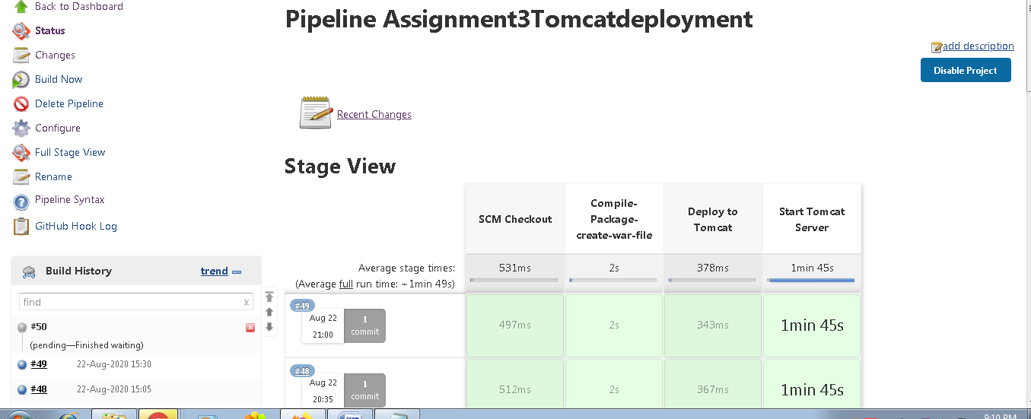

Also we can set the cron for the Automated Builds By enabling the poll scm and mentioning the timinigs as follows:

